**Interview given by Smita Purushottam**

**Chanakya, Civil Services Today, June 2011**

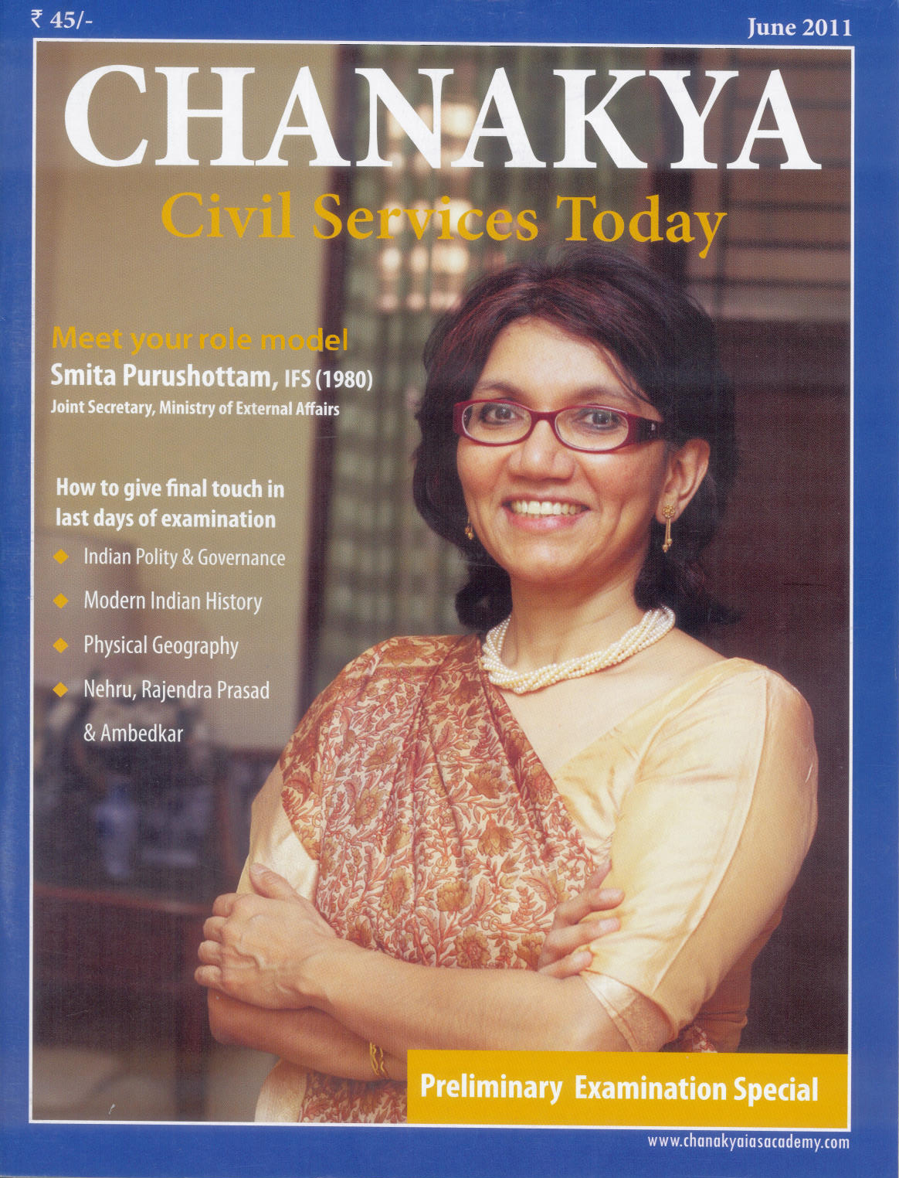

**Questions** **for** **Interview**

1. **Please tell us about your family background when you were preparing for the Civil Services Examinations?**

My late Father was in the Indian Foreign Service and my Mother used to teach whenever she could at schools or universities in between my Father’s transfers. She was the first Bihari woman to have done an M.Sc in Physics.

1. **May we please know your education and the educational institutions you attended?**

I completed an MA from Delhi University with First Class in 1979 and immediately got admission to the 2-yr M.Phil programmes at DU and JNU. I enrolled in DU since I had done my studies there and I had a marvelous guide Prof. Parthasarathi Gupta. I applied for taking the civil service exams after completing my MA in 1979. Earlier I had studied in various schools in the countries my Father had been posted to. I had to learn the local languages as a result. I also won a Fellowship for a PhD at Cornell University for the term starting September 1980, but I had to relinquish that marvelous opportunity when I learnt I had qualified for the civil services in 1980.

1. **Inspiration behind choosing civil services for career?**

My inspiration was only my Father who loved his country and felt deeply for the poor. I was also deeply impressed by the role he had played during the negotiations with the USSR on the 1971 Indo-Soviet Treaty of Friendship & Cooperation during the Bangladesh crisis, when he was in the Indian Embassy in Moscow. His sincerity, honesty, far-sightedness, vision, courage, brilliance and closeness to his roots remained my main inspiration all my life*, especially once I realised that these were not common qualities*.

1. **Once decided, how did you go for preparation along with normal study schedules?**

I took the civil services exam as one option only and did not focus my studies for the exam. My Mother was opposed to my joining the Services and felt I would make a bigger mark in Academia. So I chose the subjects I was genuinely interested in - which was History which I was doing at University and also Russian language and literature which I had kept in touch with after leaving Russia.

1. **How many years did you take to go for the first attempt?**

I qualified on my first attempt.

1. **How did you prepare for the Main examination in particular?**

Except for my close friends and family members who know what I’m saying is true, no one believes this but I did not prepare for the main exams at all, partly because I was convinced that I was too stupid to qualify. In fact my Father who had just returned from a foreign trip was unpleasantly surprised to see me in my night clothes lounging around the flat on the morning of the main exam. He told me to go and take it anyway saying it was a one in a million chance that I would qualify and I did, much to my own surprise. I remember I cycled to the UPSC centre on Shah Jahan road and came half an hour late for the first exam as a result, and the examiners looked very sorry for me as they must have thought I would fail.

1. **How to choose a subject (optional) for the main examination?**

I do not know if my experience is relevant to everyone but I chose a subject I had a deep personal interest in and had kept in touch with for many years. As a result I think I had insights into Russian literature which may have surprised the examiner. I was also a dreamer and used to have lots of ideas on literature and philosophy, which I must have written down in the exam.

1. **There has been a change in Preliminaries. Optional has been removed & CSAT has been introduced. What is your opinion about CSAT?**

If an aptitude test is professionally designed, it can be a useful screening device. But it should test for integrity, logic and intelligence and not only for knowledge. There has been some criticism of aptitude tests abroad which do not take into account racial and cultural differences. However since the government and private agencies select for efficiency, it is their prerogative to devise the test that will yield the kind of candidate they are looking for.

1. **What are the implications of the CSAT, as the aptitude of the candidate will be tested at the very first stage?**

It will lower the burden on the main examiners. That is why it needs to be responsibly devised so that deserving students are not eliminated arbitrarily.

1. **Whether it has any Implication for rural or the hinterland students?**

As I have mentioned above, there has been controversy on aptitude tests. I’m sure however that the authorities will take care to devise an inclusive test which does not rule out people from rural areas. In fact I do believe that after the pattern of tests was changed in 1980 the services have been attracting more and more people skilled in vernacular languages and the sciences.

1. **Your opinion about the Interview?**

My interview was really quite wonderful as the panel was clearly very erudite and asked me a lot of questions on the Soviet System, which I had witnessed first-hand, my interest in science and politics and my extensive reading of literature and history. They also tested my integrity by asking a specific question on a morally ambiguous situation, the details of which I do not recall since it was a specific and real situation more than 31 years ago.

1. **Did you make any special preparation for the interview?**

No I didn’t. I had no idea what to expect and spent the weeks before that working on my M. Phil. at the University and meeting my friends. At the time my parents had already been posted abroad so I was staying with a friend.

1. **What is your experience on the day of this interview? Do you suggest any change in the interview process?**

I enjoyed the interview a lot but this was more than 30 years ago. I felt that the panel and I resonated very well together and they seemed to enjoy my answers.

1. **Some of the interesting questions asked during interview?**

One of the gentlemen told me a joke about the Soviet System and asked for my comments. I laughed but became serious immediately and told him about a very interesting conversation I had had with my Russian girlfriend and her Family in which they had expressed their sadness about the fact that Khrushchev’s cemetery was lying in relative neglect even though he had done so much to reverse the Stalinist terror. I was also asked questions on existentialism and Jacque Monod’s book “Chance or Necessity” on biotechnology in evolution. I cannot decide which part was the best because I really enjoyed the interview. When I described it to my Father later he told me I would make it. I didn’t even pay attention to what he said since I was going to Cornell and I was very excited about that. But he was right.

1. **How did you take the essay section in the Main examination?**

I don’t recall the questions in the exam and the format but I remember one question about the permanent settlement in India which I really enjoyed answering since I had been studying it at University. Again I had a different take on this issue based on my research and I must have given original answers which were not borrowed from someone else. I wrote what I felt like.

1. **How did you prepare for the G.S. paper in the Main examination?**

I have always been well informed about general knowledge issues. I do remember that I answered one question about the measures taken for the welfare of children in the international children’s decade or something of the sort in which I wrote my views on the lack of progress in providing basic needs for our children very frankly. I don’t know how I was marked on that question.

1. **Do you feel any need of giving more importance to the interview than the written examinations or vice-versa?**

I had heard that excessive importance given to the interview led to the selection of elitist English speaking candidates for the services. The catchment area for the services should be broad based so I think the present balance is all right.

1. **Any suggestion in pattern of UPSC’s Civil Services Examination?**

I really have not kept in touch with the changing patterns in the civil services exams but I have noticed that more and more software engineers and people from the medical profession are entering the civil services. This seems to be a waste of the resources poured into their specialized education. The government should do something about providing prestigious and remunerative employment to people who have taken so much trouble to get their engineering and medical degrees. So perhaps the changes have to take place outside the civil services exams.

1. **How did you manage the huge stress that you might have faced during the preparation period?**

I didn’t put much store on the exams. But I do believe the exams have become more difficult in recent times and also with so many science and medical students appearing, the marking system would favour them so I do have a great deal of sympathy for the younger generation and feel that a lot of family support should be provided in the stressful period. I felt enormous stress for my University exams though.

1. **May you please tell something about the time management tactics during the preparations?**

I tend to go very deep into any subject. As a result I end up spending a very long time on any issue. However it leads to greater integrity and originality while answering and it also prepares you to take on the more unexpected questions. I have thus been able to answer questions that have never appeared before in the exams because I do my own thinking.

1. **How far newspapers and magazines were useful to you during the preparations? Will you please suggest some tips about how to utilize the resources in the newspapers and magazines?**

I read on every subject of importance to me and I try to establish a thread between different articles and pieces of information. I also organize my material in folders. We didn’t have computers in those days but I tried to do something similar. Today I would suggest that people should organize and collect as much information as possible in folders and then try to put the pieces together as in a jigsaw puzzle. New and wonderful patterns will emerge.

1. **How do you think the preparation for the UPSC is different than the academic examinations?**

As I said, I did not study specifically for the exams and just brought my academic knowledge to bear while answering the questions. But as the pattern has changed I am sure that the preparations need to be more focused and must draw upon the experiences of others.

1. **Do you think parents play any role in preparation for UPSC? How?**

Parents always play a wonderful role in supporting a child in meeting his aspirations. They must be understanding and not pressure the child too much because the child must have a fresh mind and be properly fed before the exam. The parents should also constantly praise and encourage the child and provide incentives for doing better. They should also help to coach the child.

1. **What should the parents do for the children aspiring for the UPSC?**

I think all the above.

1. **Don’t you think the Civil Services aspirant should begin the preparation from the higher secondary level itself?**

Not at all. A child should look at various options and decide on the civil service only if he/she thinks that he wants to do some good for the country.

1. **Whether coaching institute might be helpful in Civil Services exam preparation?**

I didn’t go to a coaching institute, but given the fact that exams are far more difficult and competitive now, with qualified people from all sorts of different streams now giving it, I would strongly recommend to my Son if he ever chose to give the exam that he should go for the coaching institutes which can provide guidance and share their experience with the students.

1. **Whether language (medium) of examination has any role in scoring or preparations?**

I’m sure a knowledge of the English language is of help.

1. **After spending a long time in the bureaucracy, your own feeling about the administrative services.**

I am in the Indian Foreign Service not the administrative services. I have had a lot of exposure to the finest intellects in this world and I really value that. At the same time I have always tied to pursue the developmental interests of my country through very concrete projects and measures. I have related everything I have done to the requirements of my country and this is inspired by the advice my Father gave me and the example he set over and over again. I’m happy with the work I’ve done but feel I should have focused more on domestic social and economic issues since there is a huge gap between India and the rest of the advanced world in these areas. I also think the services need to be more sensitive to the needs of the people and to new ideas and not suppress sources of constructive originality just because these don’t fit in with the old way of doing things, and shed their cliquishness and instinctive fear of novelty. Finally, I have never stopped wondering where I would be right now had I continued with my PhD at Cornell or some other career path.

1. **Your own experiences of dealing with issues related to the public?**

I have always benefited from involving people outside the services in my work as I get lots of fresh inputs, ideas and also a sense of priorities from them. I have always been rewarded by the feedback and affection that people have given to me since they feel that I’m approachable and I can communicate with them.

1. **Please tell me your impression about Chanakya IAS Academy and Chanakya Civil Services Today?**

I’m sorry I’ve never used a coaching service so I cannot comment. But I do remember reading your journals in my youth and finding them very useful and full of useful general knowledge.

1. **Any suggestions to improve the Chanakya Civil Services Today?**

I think the focus on contemporary issues and providing useful information is excellent. I wonder if the coaching material can be placed in a more provocative context to provoke people to think and to ask questions and to answer them accordingly. We need to help young people in India to think for themselves and the aim should not be to fill a person’s head only with information which he can then spill out in the exam. The aim should be to teach him to think but I am not very sure how that can be achieved through the written medium. For that one needs to take classes, pose questions and encourage the person to come up with solutions based on his research and discussions with other students.

1. **Group studies or lone study, what is your experience?**

Both have their place. Through the group one can bounce off ideas and get more information. Alone one has to do the basic vigorous work of preparation.

1. **Pl explain difference between following pre fixed words in the mains exams : analyse, comment, examine, elucidate, do you agree with the view, critically evaluate etc.**

All these terms are basically asking you for your views or take on the subject. Some of them are asking you had to dissect the argument and then give your views while others are simply asking you to elaborate on the subject. But ultimately it will depend on the subject matter that they are asking you to analyse comment or examine and my answer will have to depend on the context.

1. **Did you have any enabling influence or paralyzing influence.**

There were certain adverse developments before my interview which both shook me but also strengthened my resolve to prove myself in any test, not just the interview.

1. **How to select guide & magazine in the market?**

On the basis of their content, the number of issues that they cover, and the solutions that they propose, quality of writing and opinion. This has to be supplemented by a wide reading on development, economic, political and international relations issues.

1. **Food regime during examination.**

The food regime should be steady and stable of course but young people get stressed during exams and particularly take a lot of coffee which could be avoided. I have heard that drinking milk calms one and having fruit eliminates toxins. But during my M.A. exams (both years) I was so nervous I don’t think I ate anything for a month during the exams and had lots of coffee! I don’t recommend that at all!

1. **Sleep pattern during examination.**

This must be good and steady, but that is easier said than done. For my MA exams I remember not sleeping at all, or going to bed at 5.am. after studying the whole night and getting up by 7 to catch the Univ special to the exam. By the way I used to do that frequently throughout the year because once I picked up a book I could not put it down.

1. **Exercise – Yoga etc.**

I have till recently maintained a regular regime of exercise. I used to jog, swim, cycle and play badminton but the Dr. advised not to jog anymore so I swim nowadays. I also do a little bit of yoga but not very seriously. I need to change that as yoga is really wonderful for flexibility and back pain.

Smita Purushottam

May 2011.